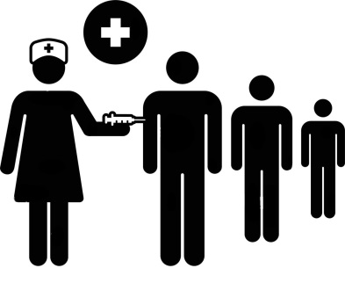
The People's Response Network
to Covid-19
https://www.facebook.com/The-Peoples-Response-Network-to-Covid-19-100425635366279

Press Release, February 12, 2022
From: The People's Response Network to Covid-19
(meetings every Wednesday, 6:00 PM CT Zoom) https://us02web.zoom.us/j/83465208585
By Phone 1 312 626 6799 US (Chicago) Meeting ID: 834 6520 8585
For Information: Howard Ehrman MD, MPH hehrman@uic.edu
University of Illinois Chicago
Assistant Professor
College of Medicine
https://www.facebook.com/The-Peoples-Response-Network-to-Covid-19-100425635366279/
prncoalition@gmail.com
https://twitter.com/ThePeoplesResp3

The People’s Response Network (PRN)
Statement Opposing the Ending of Indoor Mask Mandates

The People’s Response Network (PRN) unequivocally opposes Illinois Governor J.B. Pritzker & Chicago Mayor Lori Lightfoot’s decisions to lift Illinois & Chicago indoor mask mandates on February 28, 2022, joining dozens of Democratic & Republican governors & mayors around the country doing the same. Chicago will also end its indoor vaccine requirements the same day.

According to the CDC 98.4% of all U.S. Counties, including Cook County and all 102 counties in Illinois, are still Red-at the highest level of community transmission.

CDC Director Rochelle Walensky said Wednesday “We continue to recommend masking in areas of high and substantial transmission,” which is everywhere.

In the last week 2,300 people per day have died in the U.S. accompanied by 190,000 new daily cases. In Illinois 80 people/day have died with 4,700 new daily cases. 632,000 U.S. children were infected with COVID last week.

Only 64% of the U.S. population is fully vaccinated, only 42% with boosters, leaving more than 100 million without vaccines or boosters.

It is far too early to take off masks indoors, exposing tens of millions of frontline workers & students, particularly adults and children of color, to increased COVID infections, hospitalizations and deaths.

The World Health Organization (WHO) states: “Masks are a key measure to reduce transmission and save lives”

Instead of lifting the mask mandate, Governor Pritzker & Mayor Lightfoot must distribute millions of N95 & K94 masks to workers & students every week to drive down new transmission and infections.

The virus still exacts a significant toll on the country. When most interactions are indoors during the winter, lifting mask mandates will jeopardize any progress that the country has made over the last two years.

PRN asserts that with this decision Governor Pritzker is placing workers in danger in order to keep the economy going at all costs.

It will also make it much more difficult for schools and municipalities to defend their mask mandates from attacks from those willing to sacrifice the public’s health for profit and self-interest.

We call upon the Governor to immediately rescind this decision and reaffirm the State’s commitment to public health best practices.

None of us are safe until all of us are safe!

